Project Design Phase-II
Data Flow Diagram & User Stories

Date | 28 SEPTEMBER 2026
Team ID | SWTID-2026-4636
Project Name | AI BLOGNEST API
Maximum Marks | 4 Marks

Data Flow Diagrams:
A Data Flow Diagram (DFD) is a traditional visual representation of the information flows within a system. A neat and clear DFD can depict the right amount of the system requirement graphically. It shows how data enters and leaves the system, what changes the information, and where data is stored.

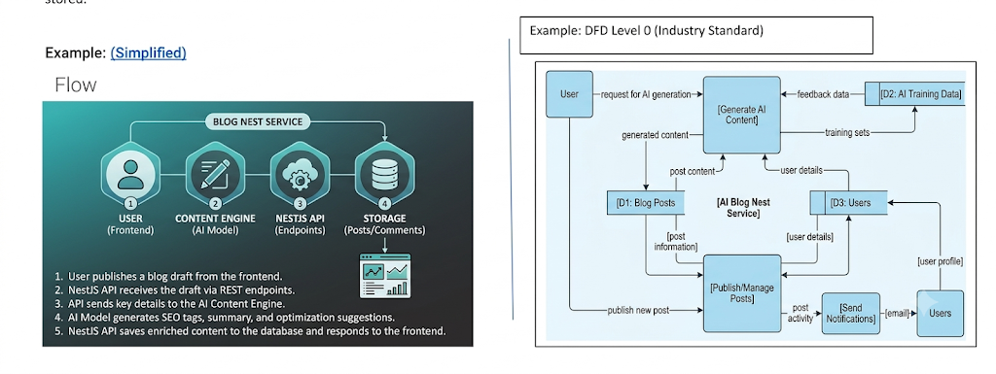
Data Flow Diagram & User Stories
- AI BlogNest API – Basic Data Flow

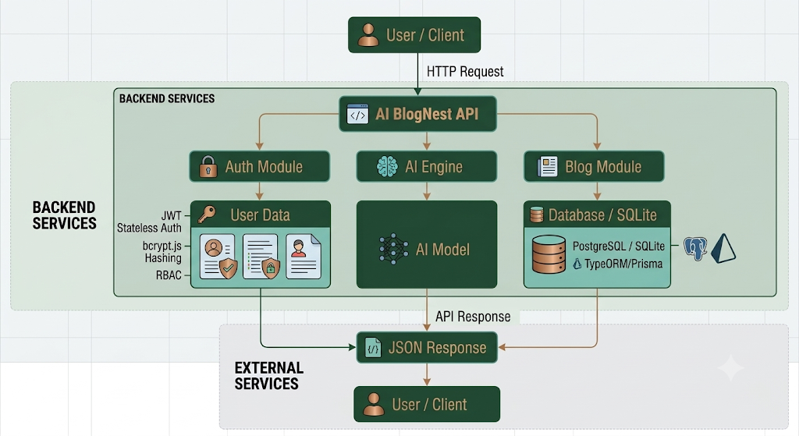

User Stories – AI BlogNest API

User Type | Functional Requirement (Epic) | User Story Number | User Story / Task | Acceptance Criteria | Priority | Release
Customer (Web User) | User Registration | USN-1 | As a user, I can register for AI BlogNest by entering my name, email and password. | User account is created successfully when valid details are provided. | High | Sprint-1
Customer (Web User) | User Registration | USN-2 | As a user, I should receive an appropriate response after successful registration. | Registration success message is returned and user details are stored securely. | High | Sprint-1
Customer (Web User) | User Login | USN-3 | As a user, I can log into AI BlogNest using my registered email and password. | Valid credentials allow login and return an authentication token. | High | Sprint-1
Customer (Web User) | Authentication | USN-4 | As a user, I can access protected APIs after successful authentication. | Valid token allows access to protected endpoints. | High | Sprint-1
Customer (Web User) | User Profile | USN-5 | As a user, I can view my profile after logging in. | Authenticated user details are returned correctly. | Medium | Sprint-1
Customer (Web User) | AI Blog Generation | USN-6 | As a user, I can generate blog content by entering a topic and category. | AI returns relevant blog content for the provided topic and category. | High | Sprint-2
Customer (Web User) | AI Blog Generation | USN-7 | As a user, I can generate suitable blog title suggestions using AI. | API returns one or more relevant title suggestions. | Medium | Sprint-2
Customer (Web User) | AI Blog Summarization | USN-8 | As a user, I can summarize existing blog content using AI. | API returns a concise summary of the submitted content. | High | Sprint-2
Customer (Web User) | Input Validation | USN-9 | As a user, I should receive a validation message when required information is missing. | API returns an appropriate validation error for empty or invalid input. | High | Sprint-2
Customer (Web User) | Blog Management | USN-10 | As a user, I can save generated blog content. | Valid blog details are successfully stored in the database. | High | Sprint-3
Customer (Web User) | Blog Management | USN-11 | As a user, I can view all my saved blogs. | API returns the user's available blogs. | High | Sprint-3
Customer (Web User) | Blog Management | USN-12 | As a user, I can view a specific blog using its ID. | Correct blog details are returned for a valid blog ID. | Medium | Sprint-3
Customer (Web User) | Blog Management | USN-13 | As a user, I can update an existing blog. | Updated blog content is stored successfully. | High | Sprint-3
Customer (Web User) | Blog Management | USN-14 | As a user, I can delete an existing blog. | Selected blog is removed successfully from the database. | High | Sprint-3
Customer (Web User) | Blog Search | USN-15 | As a user, I can search for blogs using relevant keywords. | API returns blogs matching the search criteria. | Medium | Sprint-4
Developer / Administrator | API Validation | USN-16 | As an administrator, I can validate API requests and handle errors. | Invalid requests return suitable HTTP status codes and error messages. | High | Sprint-4
Developer / Administrator | API Testing | USN-17 | As a developer, I can test all AI BlogNest APIs using Postman. | Authentication, AI and blog endpoints return expected responses. | High | Sprint-4
Developer / Administrator | API Documentation | USN-18 | As a developer, I can document API endpoints, parameters and responses. | API documentation contains endpoint details and request/response examples. | Medium | Sprint-4
Blogger / Content Creator | AI Content Generation | USN-9 | As a blogger, I can enter a topic and generate blog content  using AI. | Relevant content is generated based on the provided  topic. | High | Sprint-3
Blogger / Content Creator | AI Content Generation | USN-10 | As a blogger, I can modify AI-generated content before  publishing it. | Generated content can be edited and saved. | Mediu m | Sprint-3
Blogger / Content Creator | Blog Organization | USN-11 | As a blogger, I can categorize my blog  posts. | Blog posts can be assigned to appropriate  categories. | Mediu m | Sprint-3
Blogger / Content Creator | Search | USN-12 | As a user, I can search for blogs using keywords or  titles. | Matching blog posts are displayed in the search  results. | Mediu m | Sprint-3
Blogger / Content Creator | Security | USN-13 | As a user, I can access my blog data securely. | Unauthorize d users cannot access protected  blog data. | High | Sprint-4
Blogger / Content Creator | Error Handling | USN-14 | As a user, I can receive clear messages when invalid information is  submitted. | Appropriate validation and error messages are displayed. | Mediu m | Sprint-4
Administrat or | User Management | USN-15 | As an administrato r, I can manage registered | Administrat or can view and manage authorized user  information. | High | Sprint-4

user
accounts.
Administrat or | Blog Management | USN-16 | As an administrato r, I can monitor blog content stored in the  system. | Administrat or can view available blog records. | Mediu m | Sprint-4
Administrat or | Database Management | USN-17 | As an administrato r, I can maintain user and blog information  securely. | Data is stored and retrieved correctly from the database. | High | Sprint-4
Developer / Tester | API Testing | USN-18 | As a developer, I can test the BlogNest REST APIs  using  Postman. | All major API  endpoints return the expected responses. | High | Sprint-4
Developer / Tester | System Testing | USN-19 | As a tester, I can test both valid and invalid user scenarios. | Positive and negative test cases are completed successfull  y. | High | Sprint-4
Project Team | Deployment | USN-20 | As a project team, we can prepare the AI BlogNest API for final  deployment. | Application is tested and ready for deployment  . | High | Sprint-4

